Customer Search and Verification
User Manual

Table Of Contents

1 What are the Customer Search and Verification Features? 1
2 Accessing the Customer Search Functionality 1
3 Defining a Search 2
4 Accessing Contacts and Accounts, Once Found 4
5 Quick Search 5
6 Ticket Search 6
7 Customer Verification 7
7.1 Contact / Account Selectors 9
7.2 Account Details 9
7.3 Contact Details 9
7.4 Linked Pages 10
7.5 How Customer Verification Works 10

What are the Customer Search and Verification Features?
Flex users interacting with customers on the phone will almost always have to locate the customer’s details in Flex, and verify that the customer is who they say they are and has permission to act on behalf of the account. The Customer Search and Verification functionality facilitates this process in an intuitive and efficient manner.

Accessing the Customer Search Functionality
Customer search functionality can be accessed by two convenient methods.
The conventional way of accessing the Customer Search functionality is by clicking on “Find Customer” which is located in the “Customer” dropdown menu.
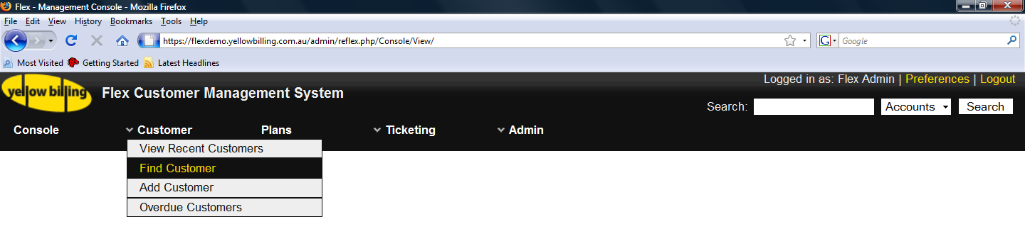
Figure 2-1 Accessing the Customer Search Functionality
All pages of Flex have “Quick Search” controls located in the top right section of the header. This can be seen in Figure 2.1. The user simply types the search term into the search textbox, selects what type of search to perform and clicks the search button. This will open the Search popup, populated with the results of the search.
The search details of the user’s last successful “Quick Search” are always remembered and preloaded into the controls.
Searching for Tickets can also be triggered from these “Quick Search” controls, but is not currently integrated into the “Search” popup.

Defining a Search
The Search popup is broken up into two sections, that being the search criteria, and the search results. Figure 3.1 shows the Search popup when no results are displayed.
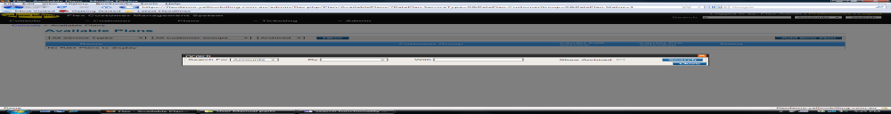Figure 3-2 Search popup, not showing search results
1 2 3 4
The search controls from left to right are:
- Search Type: Defines what type of results to retrieve. Currently the Search popup only handles searches for Contacts and Accounts.
- Constraint Type: Defines the type of value that the search string represents. Possible options include AccountId, AccountName, FNN, Invoice Number, ABN, ACN, Email Address and Contact Name
- Constraint: The search string. For example the Account Id of the account to find, or the name of the customer to find. This string is case insensitive.
- Include Archived: Check this checkbox to include archived accounts, when searching for accounts, and to include archived contacts when searching for contacts.
As an example, to search for all non-archived contacts with the contact name “John Smith”, the user would select “Contacts” from the SearchType combobox, “Contact Name” from the Constraint Type combobox, type “John Smith” into the Constraint textbox, and make sure the “Show Archived” checkbox is unchecked. They then click on the search button to trigger the search. This example can be seen in Figure 3.2 along with the results of the search.
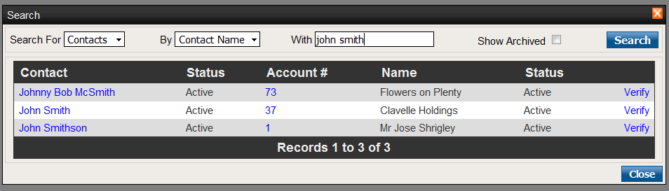

1 2 3 4 5
Figure 3-3 Search for contacts named John Smith
Figure 3.2 shows how results are displayed when searching for Contacts. These results are sorted in alphabetical order by contact LastName then FirstName. The details returned when performing a Contact search are from left to right:
- Contact Name: The contact’s name (FirstName + LastName)
- Contact Status: The status of the contact
- Account Number: The contact’s primary account
- Account Name: The name of the contact’s primary account (business or trading name)
- Account Status: The status of the contact’s primary account
Notice that the search defined in Figure 3.2 is searching for contacts with the name “john smith” and has included the contacts “John Smithson” and “Johnny Bob McSmith” in the results. Searches using the Constraint Types of “Account Name” and “Contact Name” will search for all Accounts or Contacts that contain ALL of the words in the search string somewhere in the field that the Constraint Type relates to. This is why the contact search constraining on the contact name “john smith” retrieves the contacts named, “John McSmith” and “Johnny Bob McSmith”, but would not retrieve the contact “Elly May Smith”. If the user wanted to find all contacts with “smith” in their name, they could broaden the search by simply using the search string, “smith”.
Table 3.1 defines the search constraint types available for the differing search types.
Search Type | Constraint Type | Description
Account | Account Id | Retrieves the account with the id equal to that of the search string.
Account | Account Name | Retrieves all accounts that contain the search string in either their Business Name or Trading Name
Account | FNN | Retrieves the account that currently owns the FNN, and also any accounts that are currently scheduled to take on ownership of the FNN at a future date
Account | Invoice Id | Retrieves the account which owns the invoice identified by the search string
Account | ABN | Retrieves the account with the ABN specified by the search string
Account | ACN | Retrieves the account with the ACN specified by the search string
Account | Email Address | Retrieves all accounts that have associated contacts with an email address containing the search string
Contact | Contact Name | Retrieves all contacts that have a name (FirstName + LastName) like the search string
Contact | Account Id | Retrieves all contacts associated with the account identified by the search string
Contact | Email Address | Retrieves all contacts with an email address containing the search string
Table 3-1 Search Constraint Types Specific to Search Type
The user can also choose to not specify a search constraint type, in which case, the search string is used in every logical sense. That is to say, if the search string is a number, then it will try and retrieve all accounts using the string as an account id, invoice id, FNN, ABN and ACN. If the search string is not a single number then it will try to use it as an Account Name, Contact Name or Contact Email Address.
Performing an Account search renders similar results to that of Contact searches, omitting the contact details.
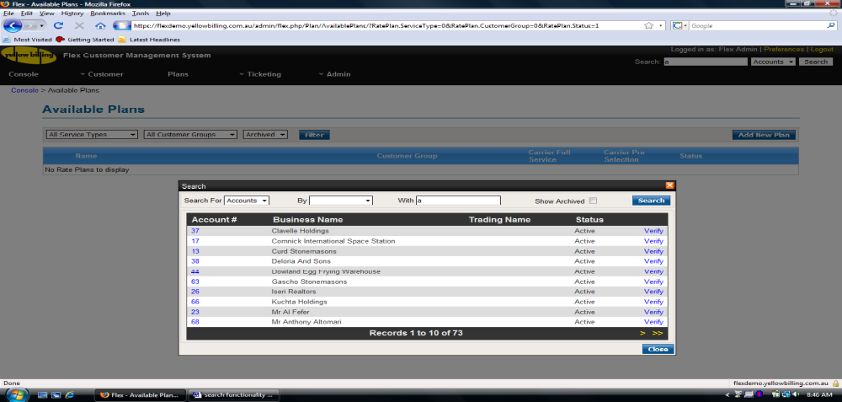Figure 3-4 Searching for Accounts
Figure 3.3 is showing the results returned by an Account search, using the search string “a” and no specific criteria type. This has retrieved all accounts that have “a” in their business name, trading name, or the email address of a contact associated with the account. These results are sorted in alphabetical order by Business Name, then Trading Name, then Account Id.

Accessing Contacts and Accounts, Once Found
It should be noted that searching for customers in this manner is to facilitate dealing with customers, when they call in, regarding their account. Customers can be verified by clicking on the “Verify” link corresponding to the account/contact returned by the search, which will open the Customer Verification popup. These links can be seen in the right most column of the search results in figures 3.2 and 3.3.
If the user has the privileges required to override customer verification then the Account Ids, displayed in the search results, will offer a link to the Account Overview page for the account, and the Contact names will offer a link to the Contact Details page for the contact.
Currently the only privilege required of a user to override customer verification is the “operator” privilege.

Quick Search
The Quick Search controls, located in the top right corner of every page, allow the user to quickly perform a search for Accounts, Contacts or Tickets, intelligently filling in the blanks in the search criteria. The only search details that the user specifies are the Search Type and the search string. The search interprets the search string in all logical contexts in the same fashion as described in Section 4, when the Criteria Type is not specified. Archived Accounts and Contacts are not included.
If the Quick Search is for Accounts or Contacts, then the results will be displayed in the Search popup, with the Search Criteria controls reflecting the search that took place.
Performing a Ticket search through the Quick Search controls will redirect the user to the ticketing page, showing the results of the search.
Search Type | Search String | Fields Searched Against
Account | Numeric | - Account Id  - Invoice Id  - FNN (if valid FNN)  - ABN (if valid ABN)  - ACN (if valid ACN)
Account | Alpha Numeric | - Account Name (BusinessName or TradingName)  - FNN (ie 0712345678i)  - Contact Email Address
Contact | Numeric | - Account Id
Contact | Alpha Numeric | - Contact Name  - Contact Email Address
Ticket | Numeric | - Ticket Id  - Ticket Subject  - Correspondence subject / content  - Ticket Contact name / email / phone number  - FNN of related services
Ticket | Alpha Numeric
Figure 5-5 Quick Search, Searching Process

Ticket Search
Performing a Ticket search through the Quick Search controls works exactly the same as the Filter textbox does on the ticketing page, as shown in figure 6.1.
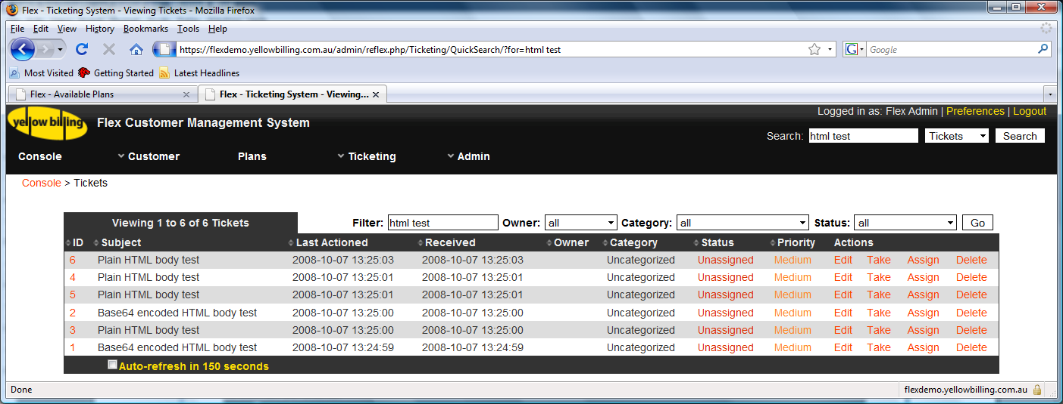
Figure 6-6 Ticket Page filtering on "html test"
The search will retrieve tickets where any of the following values match the search string:
- Ticket Number (if found, the ticket will be displayed instead of the ticket list)
- Ticket Subject
- Correspondence subject/content
- Ticket contact name/email/phone number
- FNN of related services
The results of the search are presented as a normal ticket list, with the filter textbox populated with the search string. This filter control is available when viewing any ticket list.
Due to the number of fields in the database that the search has to consider, the search currently matches against individual fields and each field has to contain ALL non-FNN search strings to be considered a match.
Using the example of a Ticket with the following details:
- Subject: Please help, my phone doesn’t work
- Correspondence content: I tried using my phone today, but it’s broken
The following search terms would find the ticket:
- “work help” : both words are contained within the subject of the ticket
- “broken today” : both words are contained within the content of the correspondence
The following search terms would not work:
- “work broken” : because only one of these words is contained in the ticket subject, and only one is contained in the correspondence content

Customer Verification
The Customer Verification popup can be opened by clicking on the “Verify” link corresponding to the Account or Contact that the user wishes to verify, in the search results popup.
Figures 7.1 and 7.2 show search results when searching for Accounts with account id 1, and the Customer Verification popup displayed when the user clicks on the “Verify” link, respectively.
Figures 7.3 and 7.4 show the search results when searching for contacts named “john smith”, and the Customer Verification popup displayed when the user clicks on the “Verify” link of the “John Smith” row, respectively.
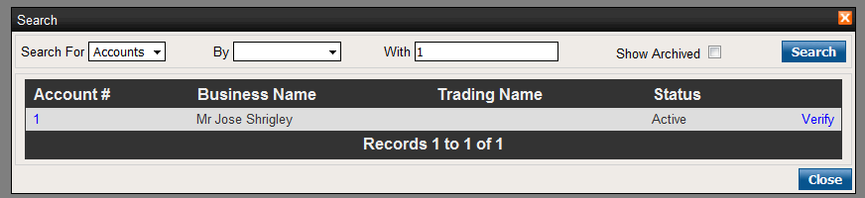
Figure 7-7 Searching for Accounts with Account Id 1
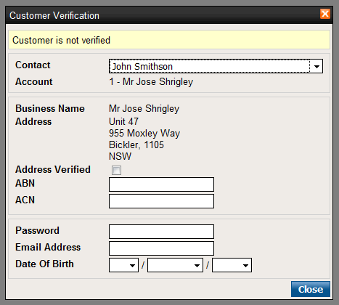
Figure 7-8 Customer Verification for Account 1

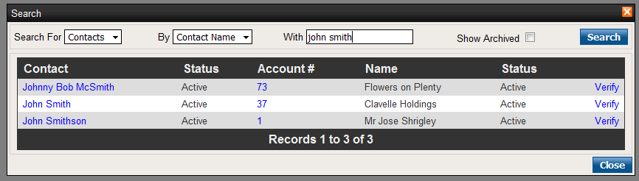
Figure 7-9 Searching for Contacts with name John Smith

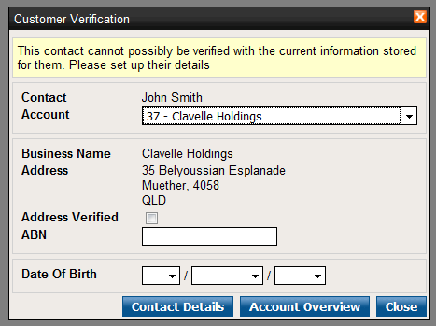
Figure 7-10 Customer Verification for Contact John Smith
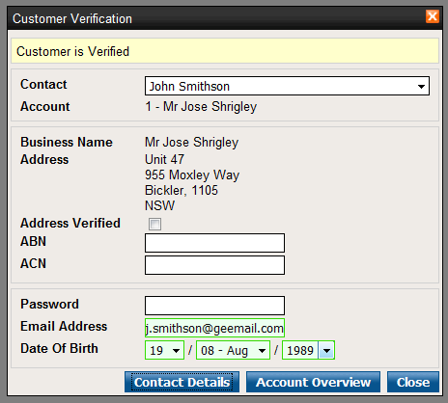
1
2
3
4
Figure 7-11 Customer has been Verified
The Customer Verification popup is broken up into four sections, as marked in figure 7.5:
- Contact /Account Selectors
- Account Details
- Contact Details
- Linked Pages

Contact / Account Selectors
The Contact Account Selectors allow the user to specify the contact or account to verify if there are multiple options. One of these two properties is always fixed.
If the initial search retrieved accounts, then the account will be fixed, and the contact combobox will be populated with all contacts that can access the account, as seen in figure 7.5.
If the initial search retrieved contacts, then the contact will be fixed and the Account combobox will be populated with all accounts that this contact can access, as seen in figure 7.4.

Account Details
This section displays the account details and controls to verify the account specific details. Currently the only Account level properties that can be verified are the account’s postal address, ABN and ACN. All accounts must have a postal address, but they may not have an ABN or ACN, in which case, these controls are not displayed, as seen in figure 7.4 where account 37 (Clavelle Holdings) doesn’t have an ACN.

Contact Details
This section displays the controls to verify the contact currently selected. Currently the only contact level properties that can be verified are the contact’s password, email address and date of birth. All contacts should have values specified for these properties when they are entered into flex, however, if for whatever reason, a contact doesn’t have an email address specified, or a password or a date of birth, the controls to verify these specific properties, will not be displayed on the page. This scenario can occur, if account and contact details have been imported into Flex from another customer management system.

Linked Pages
This will display buttons to allow the user to view the contact’s details or the account’s details, when the contact or account has been verified. Figure 7.5 displays these buttons because the contact has correctly verified their email address and password. Figure 7.4 shows these buttons because there isn’t enough information to verify the contact, so it warns the user to this fact, and displays the buttons anyway. Figure 7.2 doesn’t show these buttons because the customer has not successfully verified details of the contact or account.

How Customer Verification Works
The customer must supply enough valid information to verify either a contact, or account. When an account or contact property has been entered correctly, the control will turn green, with the exception of the Account Address verification checkbox.
Each property has a score associated with it. Table 7.1 defines the scores that each of the properties are worth when verified, and the required total score necessary to verify either an account or contact. It also defines which pages are then accessible to the user, once the account or contact has been verified.
Thing to Verify | Required Score | Verifiable Property | Property Score | Accessible pages after successful verification
Account | 10 | Address | 5 | - Account Overview
Account | 10 | ABN | 5 | - Account Overview
Account | 10 | ACN | 5 | - Account Overview
Contact | 10 | Password | 10 | - Contact Details  - Account Overview
Contact | 10 | Email Address | 5 | - Contact Details  - Account Overview
Contact | 10 | Date Of Birth | 5 | - Contact Details  - Account Overview
Table 7-2 Customer Verification Scores
Note that successfully verifying the account’s ABN and the contact’s date of birth, will not actually verify the customer, as they must score at lease 10 points with either the account properties, or the contact properties. A combination of the two will not suffice.
As stated in section 7.4, if there Flex does not have enough information about the contact, to verify them, then it will warn the user, and allow them to proceed to the Contact Details page, or the Account Overview page. This does not happen, if there isn’t enough information to verify an account.

